1. Original SFA+3 model

The advantage of SFA+3 model is that the energy transfer efficiency (ε) can be extracted without any pre-knowledge of the system (number or orientation of the dipoles). However, in order to implement this method, the system needs to meet the approximate conditions:

i) Due to three-dipole model, the orientation of dipoles needs to be symmetrically distributed along the main axis of absorption.

ii) If the system is not symmetrical, the higher the et, the lower the residue.

iii) Considering the single funnel approximation, there should be only one EET-emitter in the system, and all dipoles transfer the same amount of energy (ε) towards to it.

2. Extension of SFA+3 model using for multiple emitters

There is one special case when SFA+3 model can also work for system possessing multiple EET-emitters, as long as the system meets the following requirements:

i) The system can be split into several sub-systems according to the emitters, and each sub-system perfectly meets the requirements of SFA+3 model.

ii) The absorption polarization of all the sub-systems are the same.

iii) The sum of εi over all sub-systems is smaller than one. $ε_{1}+ ε_{2}+…ε_{N}≤1$

We can understand this extension of the SFA+3 model from the following equations. For one single funnel system, the expression of ET part is:

$$ET=ε\frac{1}{4}{[1+M_{ex}cos⁡(2[φ_{ex}-θ_{ex}])]}[1+Mfcos⁡(2[φ_{em}-θf])]$$

For multiple systems possessing the same absorption but different 𝜀 and emitters, the equation can be written as:

$$ET={\frac{1}{4}cos}^{2}{[1+M_{ex}cos⁡(2[φ_{ex}-θ_{ex}])]}\sum_{i=1}^{N}{ε_{i}[1+{Mf}_{i}cos⁡(2[φ_{em}-{θf}_{i}])] }$$

Any linear combination of cosines having the same frequency 𝜑em, but different phase 𝜃fi, is also a cosine with frequency 𝜑em, but a potentially different phase 𝜃fall and amplitude:

$${If}_{all}=\sum_{i=1}^{N}{ε_{i}[1+{Mf}_{i}cos⁡(2[φ_{em}-{θf}_{i}])] }=ε_{all}[1+{Mf}_{all}cos⁡(2[φ_{em}-{θf}_{all}])]$$

So in this particular case, the single funnel of the system will be the linear combination of individual emitters in each sub-system. And the single funnel possesses its own polarization properties relevant to individual emitters as below: [analytical solution]

3. The model does not work ideally if sub-systems possess different absorption polarization and 𝜀i. Why?

Let us assume there are three sub-systems possessing different absorption polarization and 𝜀i , but their emitter have the same polarization properties. The overall system can be split into ET and NoET parts, as shown in the cartoon. ET and NoET parts will have different absorption. However in our model, the ET part should have the same absorption as the NoET part which gives the initial orientation information of the system. Furthermore, if the sum of sub-systems does not symmetrically distribute along the excitation phase of the whole system, then the three-dipole model could also fell.

[How to see this from the equations?]

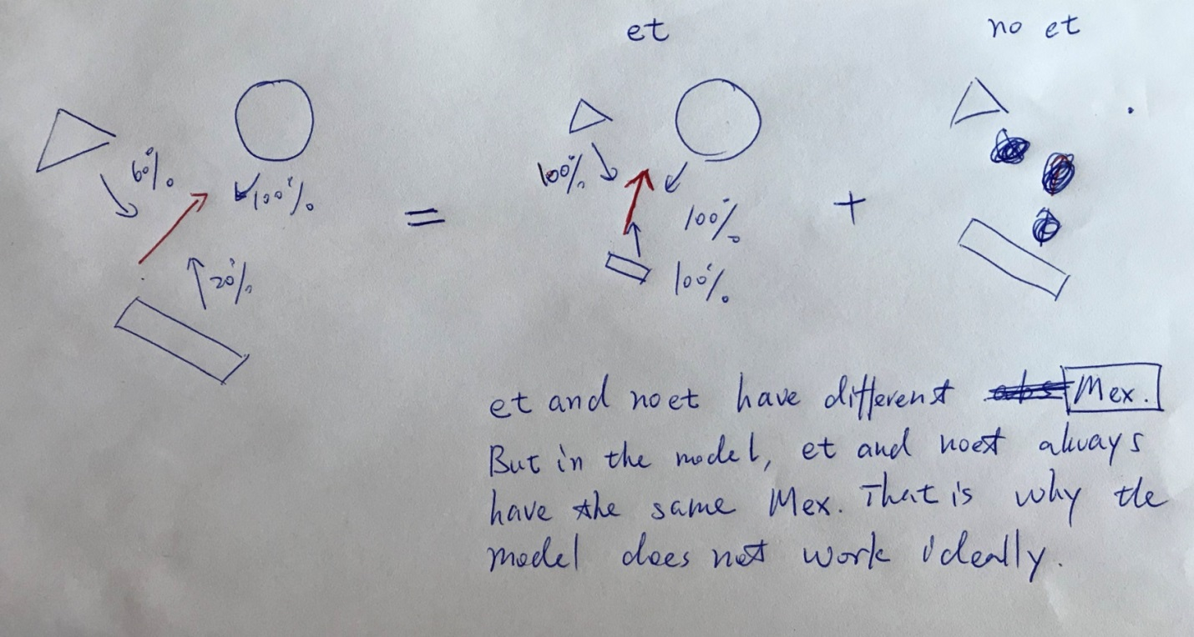

4. Improvement of the model

i) Break the symmetry of three-dipole model.

ii) Allow ET and NoET parts to have different Mex.

$$ET={\frac{1}{4}cos}^{2}{[1+Mfcos⁡(2[φ_{em}-θf])]}\sum_{i=1}^{N}{ε_{i}[1+{Mex}_{i}cos⁡(2[φ_{ex}-{θex}_{i}])] }$$

$${Iex}_{all}=\sum_{i=1}^{N}{ε_{i}[1+{Mex}_{i}cos⁡(2[φ_{em}-{θf}_{i}])] }=ε_{all}[1+{Mex}_{all}cos⁡(2[φ_{ex}-{θex}_{all}])]$$

$$ET={\frac{1}{4}εcos}^{2}{[1+Mfcos⁡(2[φ_{em}-θf])]}\sum_{i=1}^{N}{[1+{Mex}_{i}cos⁡(2[φ_{ex}-{θex}_{i}])] }$$

$$NoET= \sum_{i=1}^{N}{(1-ε_{i})\cos^{2}{(φ_{ex}-θ_{i}^{0})}}\cos^{2}{(φ_{em}-θ_{i}^{0})}$$

Case 1: same abs, different ε, different funnel

$$NoET= \sum_{i=1}^{N}{(1-ε_{i})\cos^{2}{(φ_{ex}-θ_{i}^{0})}}\cos^{2}{(φ_{em}-θ_{i}^{0})}$$